MEMORANDUMS

What is memorandum?

- Memorandums are simply letters sent within the company to serve/ circulate a certain level of written communication.
- So the memorandums are the written messages exchanged by employees for their daily official works.

Form

- Most of the large companies have their printed official notepad/letterhead especially for memorandums where the word “memorandum” appears at the top in large, bold. But there are other headings/ titles also used instead of memo: like ‘interoffice correspondence’, ‘office memo’, ‘interoffice communication’.
- Memorandums are usually short and companies have specific size for the type.
- Memos are usually not signed.

Sample Memo Format / Template
Memorandum
TO:
FROM:
DATE:
SUBJECT:
First Sentence:
Purpose of the memo
Second Sentence - Main Body:
Any Instructions or information
Closing Sentence
What is required of the reader e.g. Confirmation, answers or feedback

So are memos and letters the same?

The principles of memos and letters are the same but the difference is memos are mostly written in direct order to convey routine messages. Theses are written mainly to exchange information among people who are interested in the information only for work purposes and mostly business oriented messages.

What should be the language like in a memo:

- Memos are most of the time written in a third person style.
- Memos are written using neutral but polite tone (neither harsh nor overly cautious).
- The language should be clear, straightforward getting the message across quickly and easily.

Now let’s analyze and see the different examples from the hand-out.

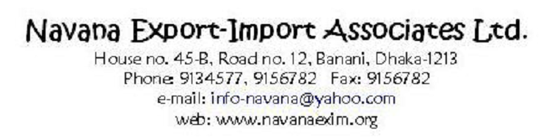

Memorandum

To : All Employees

From : Adil Manzur ; HR Director

Date : 30 November 2005

Subject: Introduction of dress code

This is to inform you that management has decided to implement the new dress
code for all employees from January 2019.

The dress codes of male and female employees will be as follows:
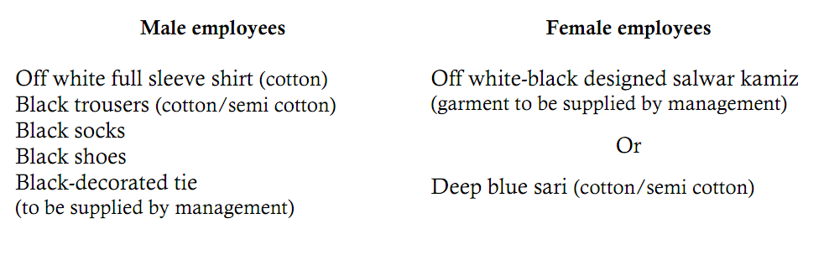

Dress code is a major way to foster employee motivation and creativity—as it helps
one in identifying oneself strongly with the organization. At the same time, it helps
the organizational environment gain a modest and disciplined look.

Utmost cooperation is expected from all regarding this new dress code.

Yours sincerely,
Your Name
Your contact details

